**SPECIFIC LEARNING DISABILITY**

According to the federal register (34 CFR 300© 10) A Specific Learning Disability means a disorder in one or more of the basic psychological processes involved in understanding or in using language, spoken or written, that may manifest itself in an imperfect ability to listen, think, speak, read, write, spell, or to do mathematic calculations, including conditions such as perceptual disabilities, brain injury, minimal brain dysfunction, dyslexia, and developmental aphasia. It does not include learning problems that are primarily the result of visual, hearing, or motor disabilities, of intellectual disability, or emotional disturbance, or of environmental, cultural, or economic disadvantage. In order to determine if Chase meets the criteria for a specific learning disability based on a pattern of strengths and weaknesses, the Dual Discrepancy/Consistency (DD/C) operational definition of SLD was applied. There are 6 diagnostic markers for the presence of a specific learning disability condition, and the following questions were used to guide the process of determining a specific learning disability on the presence of these markers:

**1.PRESENCE OF A NORMATIVE ACADEMIC DEFICIT - YES**

Chase displayed normative academic deficits that reflect an inability to achieve grade or age level expectations despite adequate instruction and supplemental interventions based on his performance on the following composites: Math Calculation (69) and Math Problem Solving (71). These areas are below what would be expected for his age/grade. These deficits are supported through various converging data sources, including teacher and parent information, curriculum-based, criterion-referenced, and norm-referenced test scores.

**2.PRESENCE OF A COGNITIVE PROCESSING DEFICIT - YES**

According to the results of formal testing, Chase has deficits in three cognitive processing areas:Visual-Statial Thinking- Gv(81), Processing Speed-Gs (75) and Auditory Processing-Ga (82).

**3.PROFILE WITHIN NORMAL LIMITS - YES**

Chase has broad intact cognitive abilities in Crystallized Intelligence, Fluid Reasoning, Short-term Memory, and Long-Term Retrieval. These are combined to create the Facilitating Cognitive Composite (FCC) of 92, which suggests Chasemost likely has average ability to learn when the attenuating aspects of his profile are removed. In addition, his G-value of .85 indicates likely average overall intelligence.

**4.EMPIRICAL RELATIONSHIP BETWEEN COGNITIVE AND ACADEMIC DEFICITS - YES**

Chase's processing speed (Gs) deficit is related to his performance in Math Calculation and Math Problem Solving. Slow processing speed leads to a lack of automaticity in basic math operations (e.g., addition, subtraction, and multiplication).

**5.DOMAIN SPECIFIC COGNITIVE WEAKNESS (ES): - YES**

Chase's deficit in Gs is significantly lower than what would be expected based on the FCC. The difference between the cognitive scores and the FCC indicates that the processing deficits are domain specific and not attributable to overall lower general ability.

**6.UNEXPECTED ACADEMIC ACHIEVEMENT - YES**

Chase's scores in Math Calculation and Math Problem Solving are significantly below what would be expected based on his FCC. However, Math Calculation difficulties are affecting his problem solving ability.

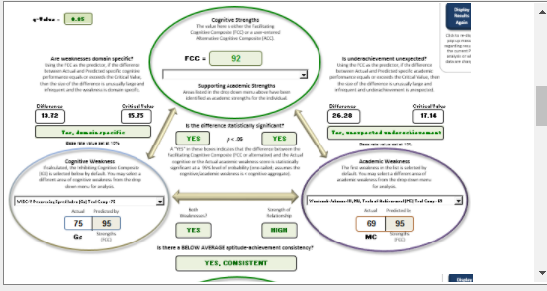

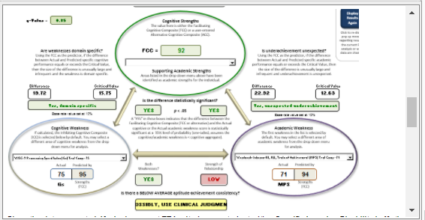

***Given the data presented, Chase does meet TEA criteria as a student with a Specific Learning Disability in Math Calculation Skills. Final determination of educational need will be made by the Admission, Review and Dismissal Committee (ARDC).***